Station A: Structure of the Battery

1. Take a look at the batteries in front of you and the diagram of a battery.

2. The magnesium dioxide is mixed with an electrolyte. They react to form an OH⁻⁻ ion. This ion flows through paper barrier, leaving the MgO₂ with a positive charge. Draw (+) charges in the magnesium dioxide on your paper.

3. The OH⁻⁻ reacts with the zinc on the other side of the paper to produce a new chemical and extra electrons. Draw (-) charges in the zinc.

4. The electrons are attracted to the positive charges in the MgO₂ but they cannot flow through the paper barrier. If you provide an external pathway, by building a circuit, the electrons will move through it due to charge attraction. Use arrows to show the direction that the electrons will flow through the circuit on your paper.

Positive Terminal

Brass “Current Collector”

Zinc outer case

Magnesium Dioxide

Powdered Zinc

Negative Terminal
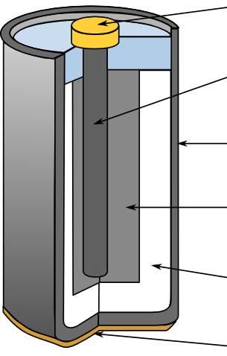

Station B: Multiple Batteries

- Close the switch on both circuits.
- Measure and record the voltage with the batteries in position A for both circuits.
- Compare the brightness of the bulbs (bright or dim).
- Rearrange the batteries of circuit 2 as shown in B, C, and D. Record the voltage and bulb brightness of each arrangement.
- Return the batteries to position A and open the switches.

 | Voltage | Brightness
Circuit 1
A
Circuit 2
A
B
C
D

Station C: Voltaic Stack

- Touch the leads of the multimeter to the ends of the battery. Was there a voltage?
- Touch the leads to the front and back of a penny. Was there a voltage?
- Touch the leads to the front and back of a nickel. Was there a voltage?

- Now, Take 10 pennies and 10 nickels.

- Cut 10 squares of filter paper about the size of a nickel.

- Stir the salt water vigorously. In the next step, you will need to dip each piece of paper into the salt water until it is completely soaked through before adding it to the pile.

- Make a stack like this: nickel on the bottom-- then paper-- then penny, nickel--paper--penny, nickel--paper--penny, etc.

- Use the multimeter to test your battery. Touch one lead to the top coin and one lead to the bottom coin. Was there voltage?

- Throw away the wet paper and put the coins back in the bucket.

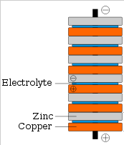
What’s happening? The two metals have a different affinity for electrons. When they are near each other, the penny pulls on the electrons of the nickel. Salt water is an electrolyte-- which means that it allows charges to flow through it. So when you have a stack of nickel-saltwater paper- penny, electrons flow from the nickel to the penny. Electricity!
Station D: Battery Types

- Complete the chart below on your own paper.
- Read the outside of the battery to find the Voltage Rating.
- To check the Actual Voltage, set the multimeter to ‘DCV 20’ and touch the red wire to the (+) end at the same time as you touch the black wire to the (-) end.
- Use the light bulb to determine which 9-volt is dead. Touch the two wires from the bulb to the two terminals of the battery.

Battery | Voltage Rating | Actual Voltage
Watch
AAA
AA
C
D
9 Volt
“dead” 9 volt

Station E: Circuit Diagrams

1. Draw a circuit diagram for each circuit using the proper symbols.

There are two types of circuits in front of you:
A and B = SERIES circuits
C and D = PARALLEL circuits

2. Open and close the switches on each circuit and observe the light bulbs. What advantage is there to having a parallel circuit? What advantage is there to having a series circuit?

3. Open all of the switches before you leave the station.

Voltage Mini-Labs Student Page NAME: _____________________________

Station A: Structure of the Battery

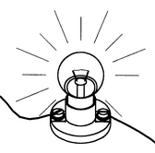

1. What does the barrier appear to be made out of?
2. What texture is the zinc?
3. What color is the magnesium dioxide?
4. Why do you think AA and AAA are called ‘alkaline’ batteries?
Station B: Multiple Batteries

 |  | Voltage | Brightness
Circuit 1 | A
Circuit 2 | A
 | B
 | C
 | D

1. What can you conclude about voltage and bulb brightness?
2. Which arrangement(s) of batteries did not turn the bulb on?
3. Why do you think this happened?
4. Look at the back of the calculator. Why do you think you have to switch the direction of the batteries?

Station C: Voltaic Stack

1. Why would the voltaic stack not work as a battery if the order were nickel-paper-penny, penny-paper-nickel?
2. Would this battery be able to light a light bulb? Why or why not?
3. On new ocean liners, there is a plastic washer between the metal sides of the ship and the bolts that hold the sheets of metal together. Give one reason why this might be.

Station D: Battery Types
Battery | Voltage Rating | Actual Voltage
Watch
AAA
AA
C
D
9 Volt
“dead” 9 volt

1. What do AAA, AA, C, and D have in common?
2. What is different about AAA, AA, C and D?
3. Does a ‘dead’ battery have no voltage?
4. How does the voltage change if you switch the wires?
5. An electronic toy calls for a D battery but you only have a AA. If you could insert the AA so that it did not fall out, what would you observe about how the toy works?

Station E: Circuit Diagrams

C
A
B

D
1. After experimenting with the switches, give an example of a real
life series circuit.

2. After experimenting with the switches, give an example of a real
life parallel circuit.

3. How does the brightness of the bulbs differ between a series circuit
and a parallel circuit? Why do you think this is?

