Ohm’s law defines the relationships among resistance (R), current (I), and voltage (V) in a circuit. Kirchoff’s Laws describe voltage and current in series and parallel circuits.

- In a series circuit (voltage/current) is constant, while in a parallel circuit (voltage/current) is constant.

- When voltage in a circuit is increased, what happens to the current? increases

- When the resistance in a circuit is increased, what happens to the current? decreases

If you put too much current through an object, like a stereo speaker, you could blow the speaker, making it useless. In order to regulate the amount of current that flows through different parts of a circuit, like the ones used to power your stereo at home, resistors are used to provide the correct amount of current to each component.

4. The batteries in your portable stereo give a combined voltage of 6V. The speakers can only handle 2 amps of current. How much resistance must there be in this circuit to keep from frying your stereo?

3 ohms

- You have a lamp in the living room that holds a 5-Ω light bulb. Your wall outlet produces 120V. What is the current that runs through that light bulb?

24 amps

6. An electric motor using a 9V battery is supplying 4.5A of current to a toy car. What is the resistance of the motor?

2 ohms

- According to the law of conservation of energy, the electrical energy from the wall outlet has to go somewhere as it passes through the toaster. What forms of energy is it transformed into?

Heat

8. A 3.0-volt source is connected to three identical bulbs as shown. A voltmeter is connected across the last bulb. What is the reading on the voltmeter?
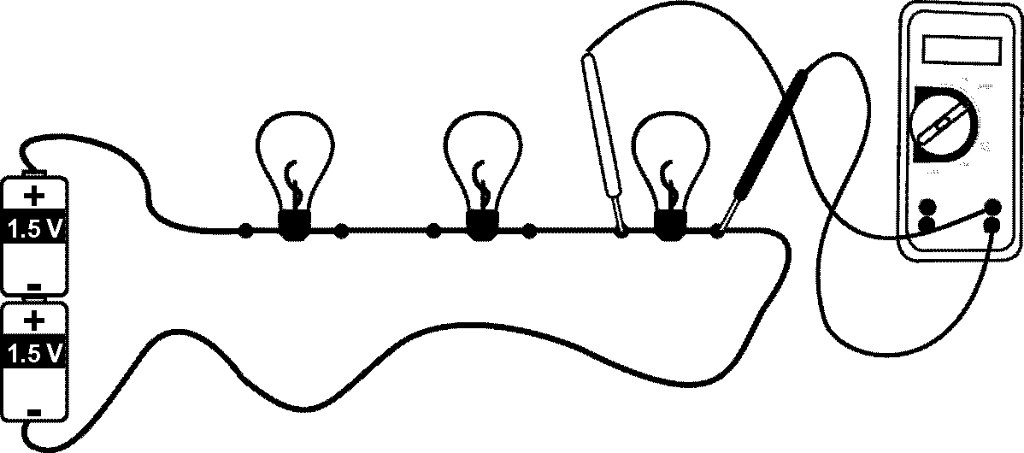1 volt

9. The circuit pictured contains 3 identical light bulbs. They are connected to a voltage source that causes 2 amperes of current to flow through each of the bulbs. Use this figure to answer the following three questions.
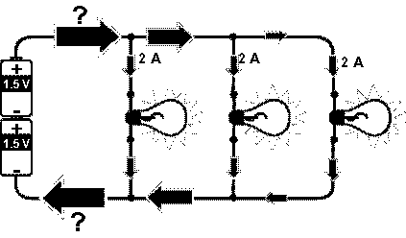
Figure 3-1

10. If 2 amps of current flow through each branch, what is the total current?
6 amps

11. How much resistance does each identical bulb have in fig. 3-1?
1.5 ohms

12. What it the total resistance of the circuit?
0.5 ohms

Three resistors, a 2-ohm, a 4-ohm, and a 6-ohm are connected in series to a 6-volt source. Use this information to answer the following two questions:

13. Draw a diagram of the circuit:

14. What is the total resistance in the circuit?
12 ohms
15. What is the current through the 4-ohm resistor?
0.5 amps

Electric power is defined as the rate at which an appliance uses electrical energy. The formula P = VI is used to determine how much power a light bulb or appliance will use. Power is also the amount of energy used in a given amount of time.

The electricity in the typical American household is 120V. A chandelier holds 8 50-Watt bulbs.

  - What is the total power of the chandelier?

400 Watts
  - How much current flows through the chandelier?
3.3 amps

19.In many homes, 75-watt light bulbs are common. If the bulb is connected to a 120-volt source, what is the resistance to the flow of charge in the bulb? 192 ohms
20. You use your 60-Watt DVD player to watch your favorite movie. How much energy does the DVD player use during the running time of the movie?

~0.67 joules (60 watts = 60 J/s, movie = 5400 seconds)

21. A 7200-Watt electric clothes dryer operates with a current of 30 amps. What is the voltage of the circuit?

240 amps

35. Which of the following diagrams represents resistors connected in in series? List all that apply.
b

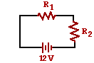
Questions #36-#39:
The diagram at the right shows two identical resistors - R₁ and R₂ - placed in a circuit
with a 12-Volt battery. Use this diagram to answer the next several questions.
36. These two resistors are connected in ____.
a. series | b. parallel | c. neither

37. The electric potential difference (voltage drop) across each resistor is ___ Volts.
a. 6 | b. 12 | c. 24
d. ... nonsense!. The electric potential difference is dependent upon the actual resistance of the resistors

38. If a third resistor (R₃), identical to the other two, is added in series with the first two, then the overall
resistance will ____ and the overall current will ____.
a. increase, increase | b. decrease, decrease
c. increase, decrease | d. decrease, increase
e. increase, remain the same | f. decrease, remain the same
g. remain the same, increase | h. remain the same, decrease
i. remain the same, remain the same

39. If a third resistor (R₃), identical to the other two, is added in series with the first two, then the electric potential difference (voltage drop) across each of the three individual resistors will ____.
a. increase | b. decrease | c. remain the same

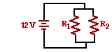
Questions #40-#43:
The diagram at the right shows two identical resistors - R₁ and R₂ - placed in a
circuit with a 12-Volt battery. Use this diagram to answer the next several questions.
40. These two resistors are connected in ____.
a. series | b. parallel | c. neither

41. The electric potential difference (voltage drop) across each resistor is ___ Volts.
a. 6 | b. 12 | c. 24
d. ... nonsense!. The electric potential difference is dependent upon the actual resistance of the resistors

42. If a third resistor (R₃), identical to the other two, is added in parallel with the first two, then the overall resistance will ____ and the overall current will ____.
a. increase, increase | b. decrease, decrease
c. increase, decrease | d. decrease, increase
e. increase, remain the same | f. decrease, remain the same
g. remain the same, increase | h. remain the same, decrease
i. remain the same, remain the same

43. If a third resistor (R₃), identical to the other two, is added in parallel with the first two, then the electric potential difference (voltage drop) across each of the three individual resistors will ____.

a. increase | b. decrease | c. remain the same

Electrostatics:

Identify the following objects as being either ...a. positive b. negative or c. neutral

i. An object possesses more protons than electrons. A

ii. An object possesses more neutrons than electrons. ABC

iii. A formerly neutral object that just lost some electrons.A

iv. A formerly neutral object that just gained some electrons.B

v. An object which attracts a negatively-charged balloon.AC

vii. An object which attracts neutral attracts paper bits and repels a negatively-charged balloon.B

viii. An object which attracts a negatively-charged balloon and attracts a positively-charged balloon.C

ix. An object which attracts a charged balloon (balloon A) which is attracted to a negatively-charged balloon (balloon B). AC

x. An object which attracts a balloon (balloon C) which is repelled by a negatively-charged balloon (balloon D). AC

xi. An object which repels a balloon (balloon E) which is repelled by a positively-charged balloon (balloon F).
A

Magnetism:

Draw the magnetic field lines around this bar magnet:

S

Draw the magnetic field lines around this wire:

. . . . . .

X x x x x

