Name: __________________________________________ Period: ___________

**TAKS Physics Review**

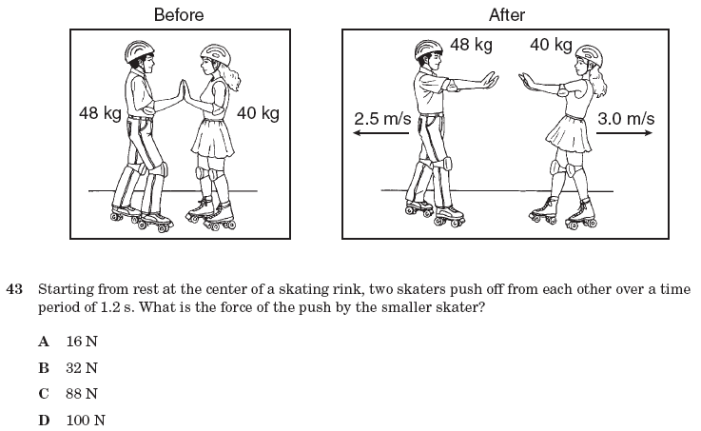

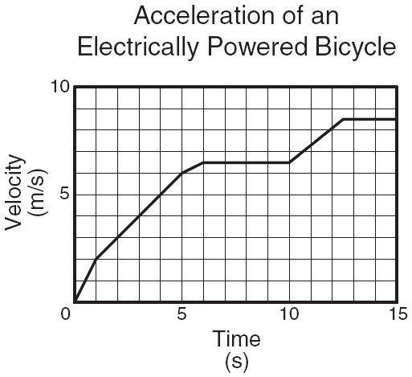

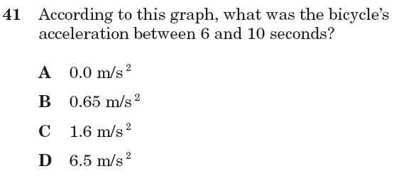

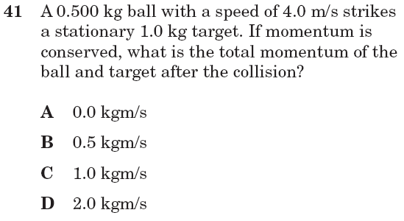

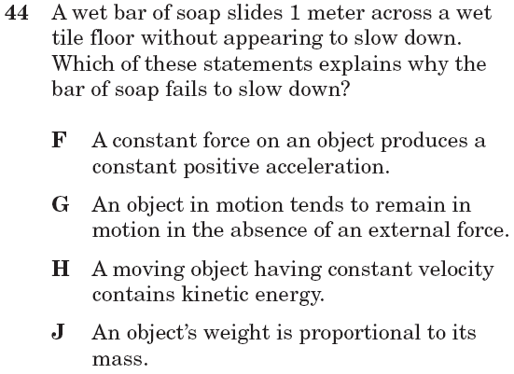

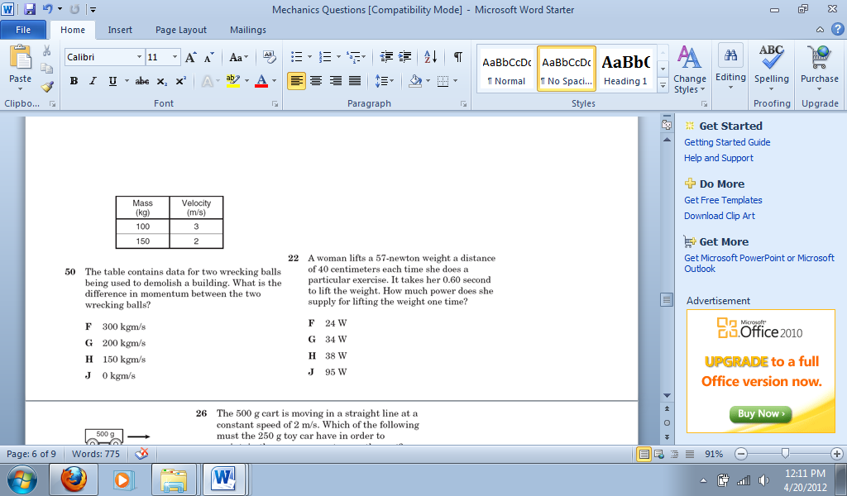

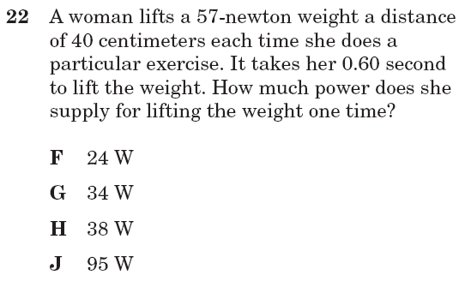

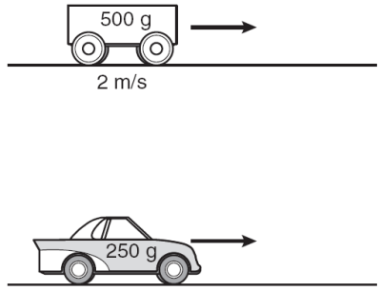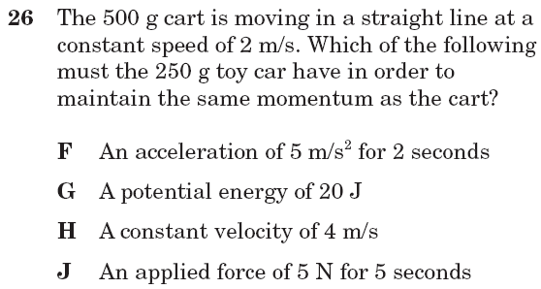

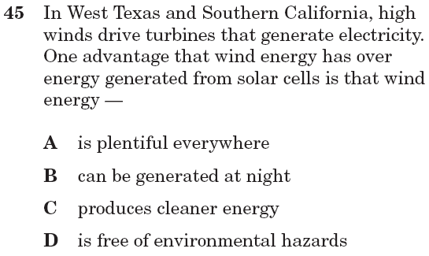

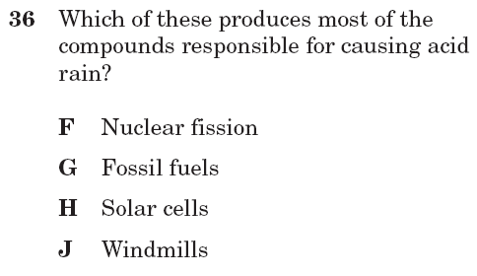

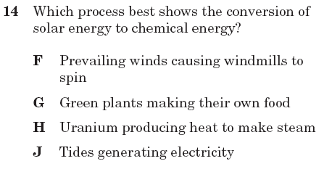

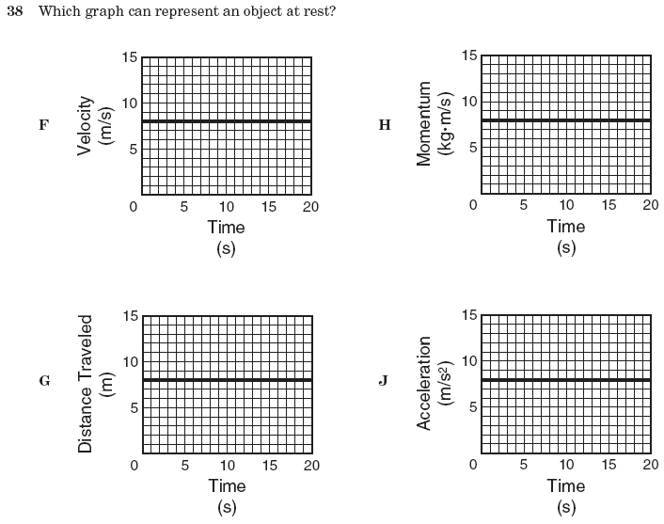





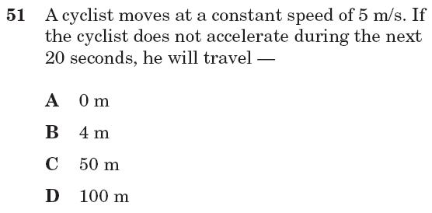

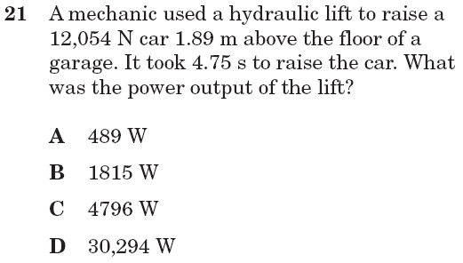

A bug walks along the edge of a table for 75 cm then turns around and walks back down the same path for 35 cm. What is the displacement of the bug from where it started?

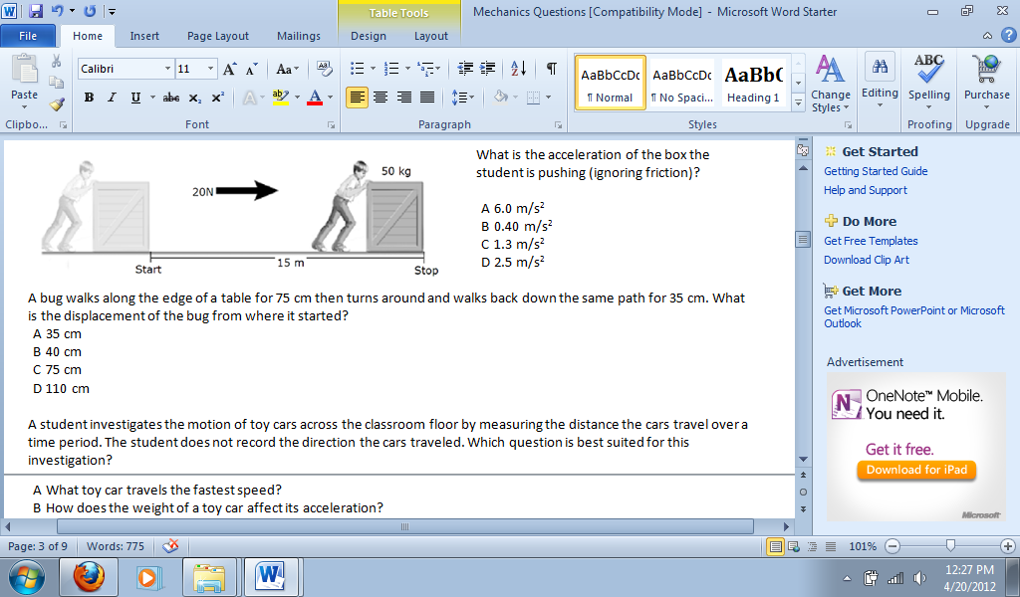

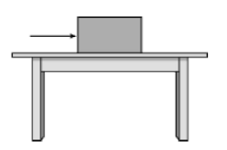

The diagram above shows a box and the direction of a force applied to the box. Which of the following vectors shows the direction of the reaction force?

|  |
| --- |
| 1. https://austinisd.schoolnet.com/files/assess_files/450252f9-678e-40c3-abe5-54f53b3ba900/da42a717-a1db-4eaf-a18f-f3e9aa8968ca.png C. https://austinisd.schoolnet.com/files/assess_files/ef8fc1de-8115-4e52-82dc-e5aff52777ae/a9814503-1838-4239-884a-2206006253ad.png 2. https://austinisd.schoolnet.com/files/assess_files/a1a1f399-39e6-4c2d-b752-76e06c541d96/7e367d0a-d4a5-49be-b6dc-030c94a9f4e7.png D. https://austinisd.schoolnet.com/files/assess_files/0eb5f6f6-04f1-4b84-8763-0b8cbeec79de/5dc6f1e3-8f49-4bab-bf3d-ab060e361773.png |
|  |

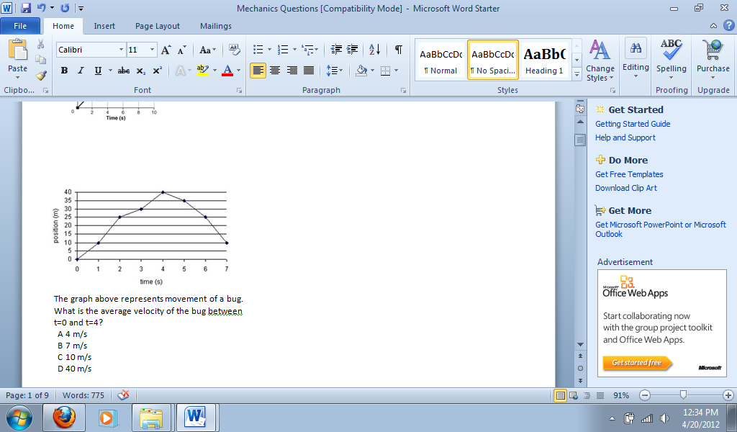

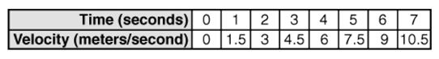

Which graph represents the data found in the table above?

|  |  |  |
| --- | --- | --- |
|  |  |  |
|  |  |  |
|  |  |  |
| https://austinisd.schoolnet.com/images/status_private.gif |  |  |

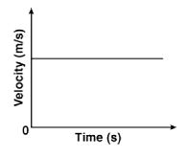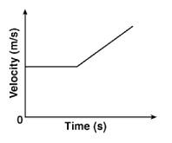

A C

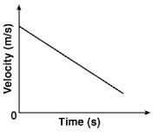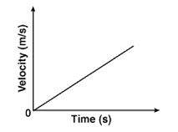

B D

